**Задание по поиску 4110-2-Дом**

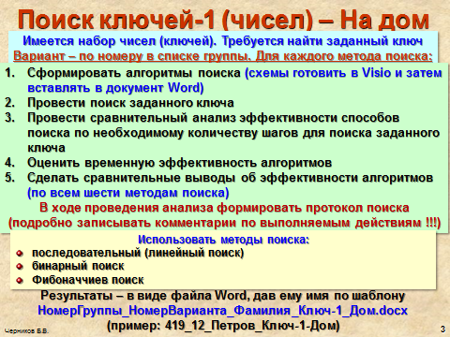

|  |  |
| --- | --- |
| **Вариант** | **Заданный набор ключей** |
| **15** | 4,6,7,9,10,12,14,15,17,19,21,24,25,26,26,28,34,35,38,41,41,46,48 |
| **16** | 5,6,7,9,10,13,15,16,18,19,19,26,26,27,27,29,29,35,36,38,45,49 |
| **17** | 1,2,7,8,12,15,17,19,27,27,29,36,39,42,42,47,57,59,63,63,64,68,73 |
| **18** | 5,6,9,10,14,15,17,19,22,24,26,28,33,33,42,42,47,47,58,59,61,68 |
| **19** | 13,15,16,17,19,22,23,25,26,28,35,37,41,41,47,47,48,49,71,78,83 |
| **20** | 6,6,8,9,16,19,21,26,27,28,35,35,48,48,51,53,59,67,72,78,83,84 |
| **21** | 2,23,23,36,38,42,47,53,56,69,69,73,73,78,78,82,82,84,89,91,93 |
| **22** | 4,6,8,9,11,14,16,17,18,20,20,21,23,24,26,26,33,36,38,39,42,47 |
| **23** | 2,4,6,8,11,12,13,14,15,17,18,20,21,21,24,26,28,31,34,37,39,39 |
| **24** | 2,3,4,7,8,9,11,15,22,22,27,31,31,36,36,42,46,48,49,60,67,68,79 |
| **25** | 2,5,8,9,9,12,12,16,18,23,26,29,31,36,38,45,58,89,93,95,98,100 |
| **26** | 7,8,12,16,19,21,21,27,34,34,39,40,42,46,48,49,53,54,57,59,70 |
| **27** | 1,1,3,3,5,5,8,8,12,14,16,17,18,19,21,23,26,29,34,39,45,67,78,89 |
| **28** | 2,3,4,7,8,9,12,15,22,22,28,31,31,36,36,42,46,47,49,60,67,68,79 |
| **29** | 3,4,6,9,10,14,16,17,18,18,20,20,21,21,25,26,28,39,56,67,69,72 |
| **30** | 4,6,8,9,12,14,16,17,18,20,20,21,24,24,26,26,34,36,38,39,42,47 |
| **31** | 1,4,7,9,10,12,15,16,17,25,25,27,28,29,30,31,37,38,47,49,52,56 |
| **32** | 2,5,7,8,9,11,13,15,16,18,19,23,25,26,28,29,29,31,37,39,41,46 |
| **33** | 3,5,6,8,9,12,14,16,18,19,21,26,27,28,28,32,36,38,39,45,47,48 |
| **34** | 2,4,6,8,10,12,13,14,15,17,18,20,21,21,24,27,28,31,35,37,39,39 |
| **21** | 3,3,4,5,7,8,9,10,13,15,15,16,16,18,18,24,26,28,29,34,37,39,41,42 |
| **22** | 3,4,7,8,10,15,17,19,22,24,24,26,28,31,35,38,43,56,58,58,63,68 |